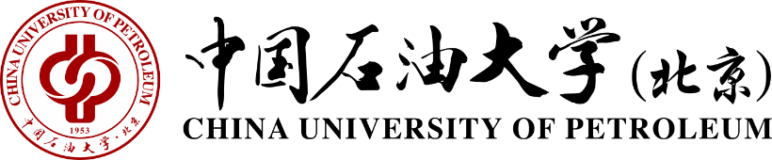
中国石油大学（北京）教务处
Academic Affairs Office, China University of Petroleum

Certificate of Graduation
June 28th, 2018
This is to certify that Mr./Ms. ZHANG Weimin, born on Oct. 10, 1999, has studied at China University of Petroleum-Beijing, as a four-year fulltime undergraduate on the program of Mechanical Design & Manufacturing and Their Automation from September 2007 to June 2011. Upon completing and passing all the required courses of the program, he/she is hereby awarded this certificate of graduation.
Certificate No.114141200000000000

地址：北京市昌平区府学路18号
电话：010-89739131 邮箱：xueji@cup.edu.cn
Add：No. 18, Fuxue Road, Changping District, Beijing
Tel ：010-89739131 Email：xueji@cup.edu.cn

