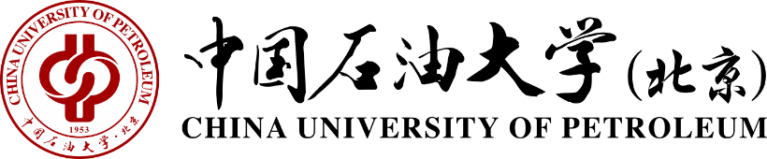
中国石油大学（北京）教务处
Academic Affairs Office, China University of Petroleum

Bachelor’s Degree Diploma
June 29th, 2020
This is to certify that Mr./Ms. ZHANG Wenming, born on Jan. 18, 1982, has completed a four-year undergraduate program of study in Information management & Information Systems. He/She has fulfilled in full the requirements for a bachelor’s degree at China University of Petroleum-Beijing, and is hereby awarded the Bachelor’s Degree of Administration, in accordance with the Constitution of China University of Petroleum-Beijing.
Certificate No.1040000000000000

地址：北京市昌平区府学路18号
电话：010-89739131 邮箱：xueji@cup.edu.cn
Add：No. 18, Fuxue Road, Changping District, Beijing
Tel ：010-89739131 Email：xueji@cup.edu.cn

